**A HOLISTIC VIEW OF NATIONS IMPACTED BY TERRORISM**

**Overview:**

The Global Terrorism Database (GTD) serves as an open-source repository of information pertaining to terrorist events worldwide, spanning the period from 1970 to 2017. Subject to annual updates, the database encompasses both domestic and international incidents, aggregating data from over 181,691cases. Each GTD entry details the date and location of the event, the weaponry employed, and the target, the number of casualties, and the identified perpetrator or group when ascertainable.

The statistical data within the Global Terrorism Database is derived from diverse open media sources, with inclusion contingent upon the verification of source reliability. GTD entries strictly furnish information about the incident without implying additional consequences or outcomes. Users are advised against assuming that an individual associated with a specific event has undergone trial or conviction for terrorism or any other criminal activity. Entries may be revised as necessary should new documentation become available.

The National Consortium for the Study of Terrorism and Responses to Terrorism (START) has facilitated online accessibility to the GTD, aiming to foster a comprehensive understanding of terrorist violence. This initiative, in turn, supports endeavors to analyze and prevent such incidents.

**Information about the Data:**

**Columns**:

nkill: number of confirmed fatal

iyear: year of terrorist attack

city: city or town in which incident took place

targtype: general type of target/victim

targsubtype1: more specific target category

attacktype1: general method of attack and strategies employed to carryout terrorist activity

gname: name of the group that carried out activity

nperps: total number of terrorists participating in the incident

**Quality of the data:**

As there are many missing values and unwanted columns, we handled all of them in the data cleaning process.

**QUESTIONS THAT DROVE THE ANALYSIS:**

1. Which countries have been most affected by terrorism?
2. Which cities have been most affected by terrorism?
3. Which type of people does terrorists is targeting and what are the weapons that they are using most?
4. Which year and region has most kills?

**Visualization – 1: Analyzing number of kills across the world**

Figure 1: Analyzing number of kills across the world

Among all the nations, according to Global Terrorism Index the country which exhibits highest number of deaths is Iraq (78,589) followed by Afghanistan (39,384). And then followed by Pakistan (23,822) and Nigeria (22,682). The moderate number of killings took place in countries like Russia (4308), USA (3771), South Africa (2674), and China (1008). Though these are powerful and large area countries we can see there is only moderate terrorism. This might be cause of the tight security those countries have imposed and because of their strong military forces. In the lowest rate we have countries like Iceland (0), New Zealand (1), Australia (23), Finland (11), Sweden (22), and Mauritius (0). This is because there is hardly any population in countries like Iceland and Fiji and New Zealand has implemented strict gun laws and has given more importance to security of its citizens. Finland has also been recognized as happiest country in the world for 6 times in a row according to World Happiness Survey. These are pretty much the insights which we could draw from the above map chart.

**Business Insights**

* **Geographic bases:** Determine which areas or nations experience the greatest number of terrorist attacks. Peacemaking organizations can evaluate the risks involved in operating in particular areas with the aid of this insight and modify their strategies accordingly.
* **Demographic evaluation**: We can compare the population densities in countries with high terrorism rates and take measures to handle such population with proper security to mitigate terrorist activities.
* **International association:** World leaders can conduct meetings with countries like Australia, New Zealand, Germany where there is minimal terrorism so that they could exchange information and policies which are in action in such countries. It could be helpful in monitoring and ensuring peace in terrorism prone countries like Syria, Afghanistan etc.

**Visualization – 2: Top cities with most kills**

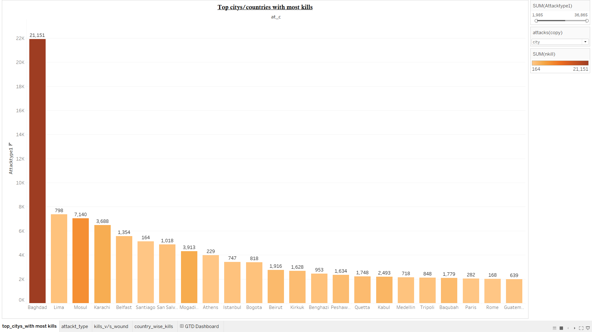

The above chart represents a vertical bar chart for the cities, attack count and count of people who are dead in attack. Here, we need to determine which cities are most impacted by terrorism from this graph and I have used the color coding to enhance the visual appeal and differentiating each bar with different colors based on count of people who died in attack. The graph shows that the total attack count is 36,865 and the nkill is 21,151.

From the graph, if we analyze “Baghdad” City which is the capital of “Iraq” has the most number of attacks and kills with 21,921 and 21,151. Next “Lima” and “Mosul” is having the more attacks and kills with a slight variation in these two cities.

**Business Insights**

* **Strategies for Reducing Risk:** Businesses can utilize this information for "Global Risk Assessment," and they can create safety standards and train people who operate in high-risk locations accordingly.
* **Resource Allocation:** Businesses can make strategic resource allocations using this information. Different security measures may be needed in cities with high attack rates but a low death rate than in those with higher crime rates.

**Visualization – 3: Trends on selection of arms in attacks**

**3.1: Visualization for attack type and targeted people**

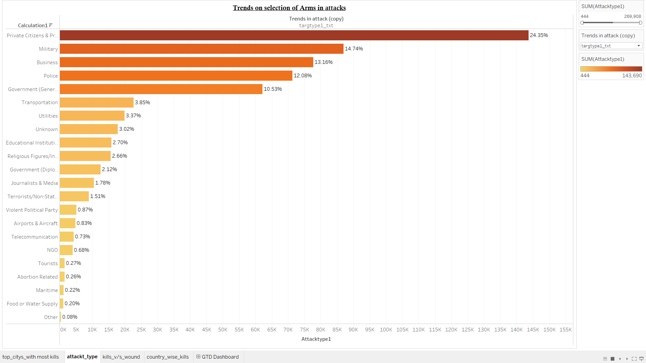

The above horizontal bar chart represents a relation between attack type and targeted people. The main reason for selecting a horizontal bar chart makes it simple to compare and order categories. Sort the data based on attack count so that we can easily identify the targeted people with most attacks.

If we look into the graph, “Private Citizens and Property” has the most number of attacks with 24.35%, next they are majorly focusing on “Military” with the count of 14.74% and “Tourists”, “Abortion Related”, “Food or Water Supply” has least number of attacks with 0.26% (with slight variation).

**Business Insights**

* **Recognizing High-Impact Attack Types:** Businesses can determine which terrorist attack types result in the greatest number of persons targeted, by looking at the horizontal bar chart. Planning ahead and risk evaluation both depend on this information.
* **Plans for Crisis Management:** Businesses has to identify the dynamics between targeted people and attack type to adapt security protocols. For instance, if the attack is against the transportation then businesses can enhance security at transit hubs.

**3.2: Visualization for attack type and weapons used**

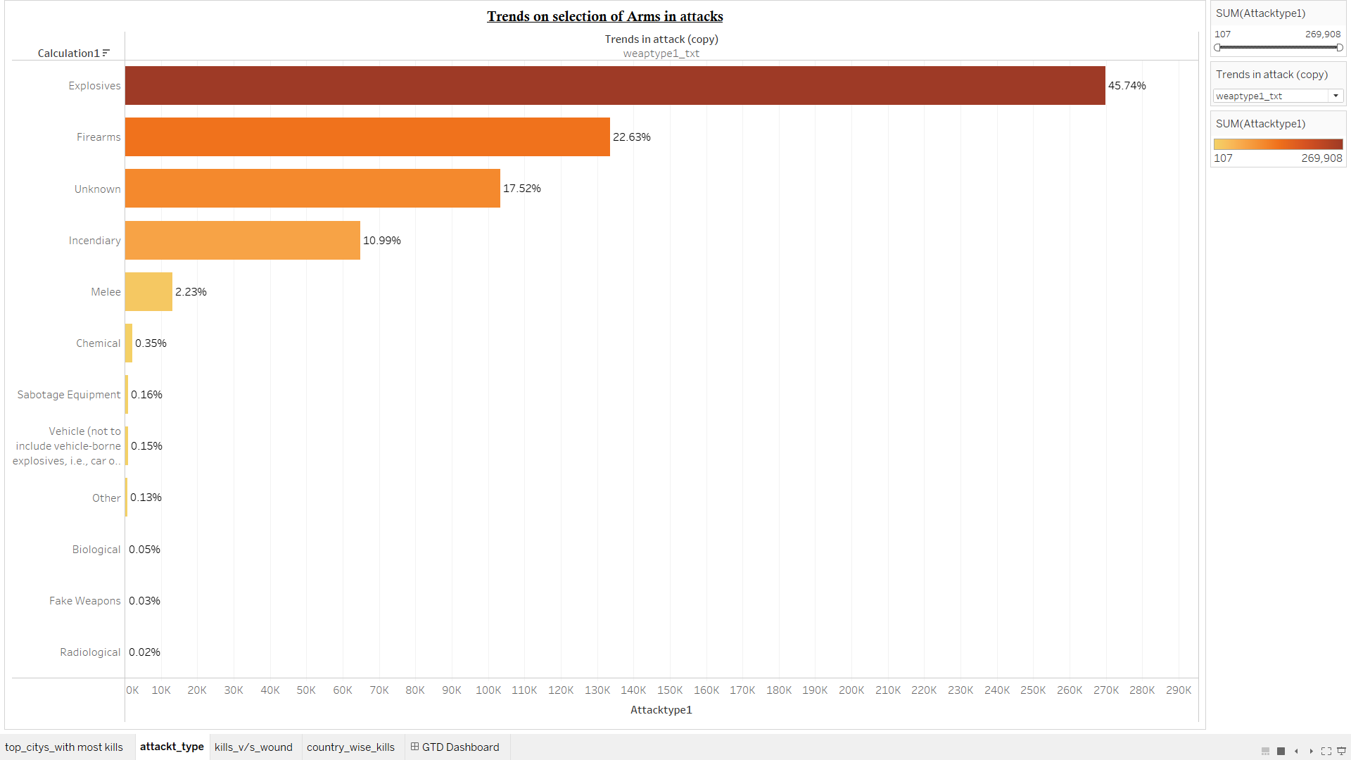

The horizontal bar graph above depicts the link between weapon type and attack type. By looking at the different weapon types listed on the y-axis, this includes explosives, firearms, chemical, etc. and each type has its own label. If we compare the bars then higher bar represents a higher percentage of attacks using that weapon.

If we analyze the above graph, “Explosives” is the most used weapon in attacking with 45.79%, next “Firearms” is mostly used with 22.63% and “Radiological” is used very least for attacking with 0.02%.

**Business Insights**

* **Innovation and Technology:** Businesses can involve security technology based on weapon type they are using mostly to attack and this could involve enhanced screening technologies, threat detection systems, or security infrastructure.
* **Logistics and Supply Chain:** Businesses that have international supply chains may need to take terrorism risk into account when organizing distribution and operations. Certain shipping and storage decisions may be influenced by the likelihood that a given attack type will target a particular transportation method or route.

**Visualization – 4: Kills v/s wounds**

The above chart provides a dual-axis line chart for the number of kills indicated by the purple color and the number of wounds indicated by the yellow color. The x-axis represents the years, ranging from 1970 to2017. The y-axes on the left and right represent the count of kills and wounds, respectively, with both axes ranging from 0 to a number above 45,000.

The analysis of the dataset reveals significant insights into the impact of terrorist activities over the years. On average, there have been around 8,763 fatalities annually due to terrorism, with the least deadly year recording 173 deaths. In contrast, the most lethal year saw a staggering 44,490 deaths. In terms of injuries, the average stands at approximately 11,146 per year, with the minimum in a year being 82 and the maximum reaching 44,043. Notably, the year 2014 was marked as the deadliest with the highest number of fatalities, while 2015 was the most injurious, recording the most number of people wounded in terrorist incidents. These statistics underscore the fluctuating nature of terrorist attacks and their devastating human toll over the past several decades.

**2014 had the highest number of kills -**

With 44,490 deaths and 41,128 injuries, 2014 was the deadliest year in the dataset. This could be attributed to the rise of ISIS and the intensification of conflicts in the Middle East, particularly in Iraq and Syria.

**Significant event in 2014 -**

In June 2014, there was a major event in Iraq that resulted in a large number of kills, which is likely to have contributed to the peak in the chart for that year.

**2015 saw a slight decrease -**

There were 38,464 deaths and 44,236 injuries in 2015. The slight decrease in deaths compared to 2014 might indicate some success in counter-terrorism efforts or changes in conflict intensity.

**Notable event in 2015 -**

In April 2015, another significant event occurred, again in Iraq, which contributed to the high number of fatalities for that year.

**2016 and 2017 trends -**

The data shows that while the number of kills remained high in 2016 and 2017, there was a noticeable decline in 2017, which might suggest an improvement in the global security situation or the effectiveness of peacekeeping and counter-terrorism measures.

**Business Insights**

* **Casualty Trends:** The average annual kills are approximately 8,763, with a median of 6,966, indicating that while some years have extremely high fatalities, the typical year is less severe. The peak number of kills in a year reached 44,490. For wounds, the average is around 11,146 with a median of 7,162, and the peak at 44,043, suggesting a similar distribution.
* **Yearly Extremes:** The year 2014 had the highest number of casualties, combining both kills and wounds, while 1971 had the lowest. This point to a significant escalation in the severity of terrorist attacks over time.

**Visualization – 5: Dashboard**

Figure 2: A Holistic view of nations impacted by Terrorism.

With the help of this dashboard, policy makers and stake holders can arrive at a decision as to which countries are more prone to Terrorism and take necessary actions in such territories and increase military their countries security forces.

If we look at the map chart and increase the slider a little, we get mainly two nations which are adversely impacted by global Terrorism which are Iraq and Afghanistan. This is because of various factors like weak governance, poverty and socio-economic issues running in their countries. It is quite evident from news that the powerful terrorist groups like ISIS and Taliban are actively operating in these two lands since decades. UNO leaders should focus more and quickly resolve the issues running and foster peace and harmony. If we look at the second chart Top city/countries with most kills, cities like Baghdad and Mosul are in the lead and these two cities are from Iraq. This clearly shows Iraq is in immediate need of care and attention and officials and even the public must investigate and create policies or generate solutions which could save Iraq from further devastations.

In the Third chart i.e., Trends on selection of Arms in attacks there is maximum utilization of Explosives and Firearms while executing terrorist activities. This clearly states that there needs to be a strict watch on the manufacture of arms and the hotspots where these arms are being manufactured and ban such businesses. Government agencies should also take care of the licenses being issued to the public so that they can control circulation of explosives and arms in the world. The vehicular explosions and radiological chemicals usage is minimum so we can ensure that there is not much focus on radioactive elements like uranium and atom bombs.

In the last line chart, we see dual charts depicting the number of wounds or injuries caused and the number of killings occurred. There is high rise of terrorist attacks in the year 2014. According to stats and reports presented by a team in University of Maryland there have been 13,463 terrorist attacks worldwide which included 32,700 deaths and 34,700 injuries in 2014 it. This was the reason we could see a spike in the year 2014. The mass 9/11 attack in the US took place in 2001 and there is a huge rise in the line chart in 2001 as well. All these are clearly shown by the line chart here.

**Business Insights**

* **Estimation and Forecasting:** Drawing common conclusions and estimating future risks that may arise in hotspots or prone areas, we can assess the trends shown above in all three charts. In this way, the security personnel can plan for resource allocation and respond quickly to any sudden threats or hazards.
* **Effect on Industrial sectors:** Given how that would affect the country's employment and economic conditions, it is obvious that no business or organization will be interested in establishing a plant there. In the long run, this will cause a significant loss to the tourism and industrial sectors, which will have an adverse effect on the state's economy and the lives of the country's youth and children.
* **Time of Response and Recuperation:** Just consider how long it will take to make up for the lost property. It takes a while, which slows down the country's development and has an impact on the financial system and other national sectors. Costs and investments to support the national economy will be part of this as well.
* **Concentration required on Iraq and Afghanistan:** Given the severity of the terrorism that exists in these two countries, world leaders ought to take the required steps to bring about peace and harmony, as doing so will inevitably lower the rate of terrorism in the future contributing to world peace.

**Unexpected Findings**

* There are more number of kills occurring from the top 3 regions are ‘South Asia’, ‘Sub Saharan Africa’, ‘Middle East’.
* There are instances where the 'success' flag is set to 0, indicating unsuccessful attack, but there are non-zero values for 'nkill' or 'nwound', suggesting there were casualties or injuries. This is insufficient and should be investigated further.
* The following target types have the most kills that is private citizens and property, military, and police are the most vulnerable target types.
* Events having no defined day or month and some events are documented with no precise day or month.
* Some attacks have duplicate records in the dataset.

**Recommendations for the governments**

* **Strengthening Security in Hotspot Regions**: Focus on countries and cities with the highest incidence of terrorism, such as Iraq or cities that frequently appear in the dataset with high casualty counts.
* **Counter-Explosive Measures**: Since explosives are the most commonly used weapon, improving detection and neutralization technologies, as well as intelligence operations to disrupt supply chains, could be effective.
* **Protecting Civilians and Property**: With private citizens and property being common targets, enhancing public security measures, and community policing could help deter attacks and reduce casualties.
* **International Cooperation**: Collaborate with other nations, especially those with low incidence of terrorism, to understand and implement best practices in prevention and response.
* **Addressing Underlying Causes**: Engage in diplomatic efforts and support initiatives aimed at addressing the root causes of terrorism, such as political conflict, economic disparities, and social injustices.
* **Public Awareness and Preparedness**: Increase public awareness about the signs of potential terrorist activities and ensure that people know how to respond in the event of an attack.
* **Research and Analysis**: Continue to analyze terrorism data to identify patterns and trends that can inform policy and operational decisions.